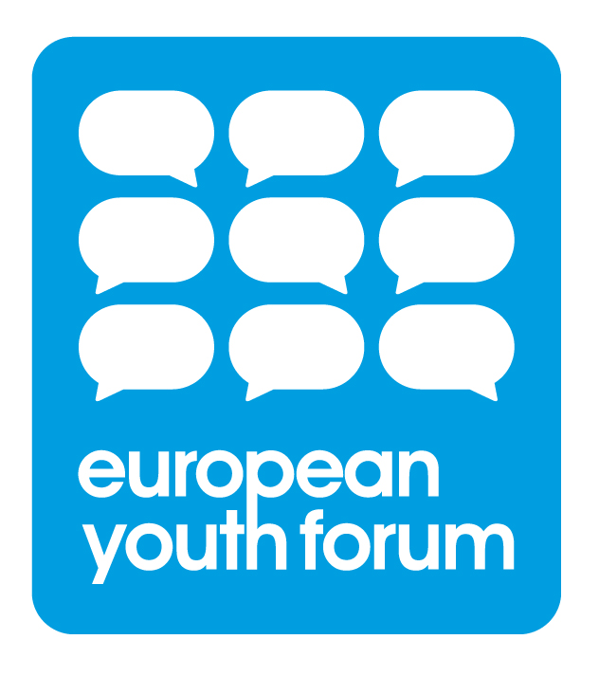
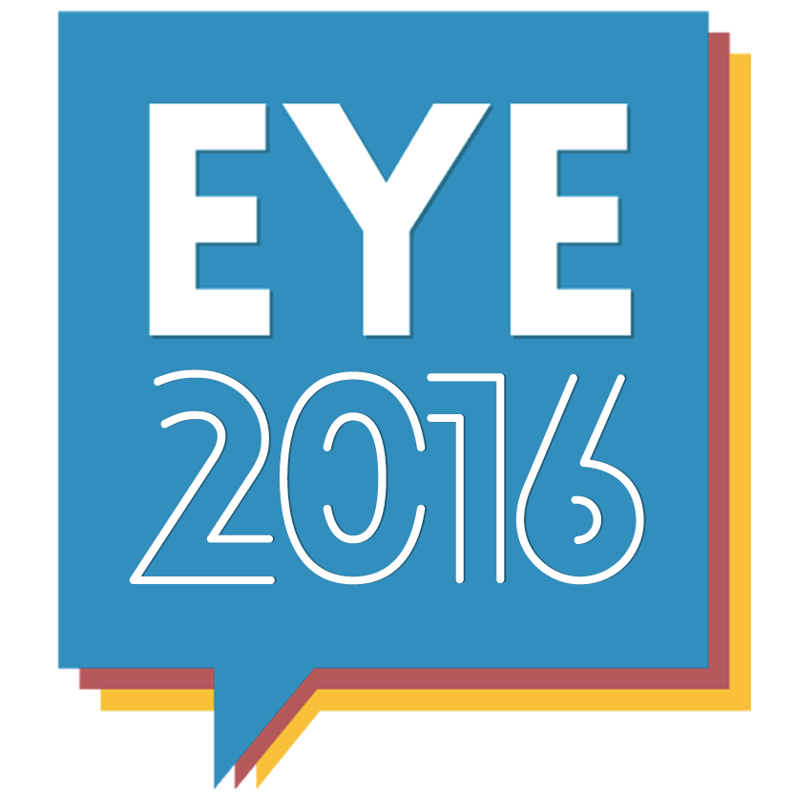
European Youth Event:

Call for YO!Fest Partners

Deadline
04/09/2015

Important Message
This call is for youth organisations that wish to become YO!Fest partners and to bring a group of participants to the EYE in 2016. Individuals should not apply to this call and will need to be part of a registered group to attend the event.

Organisers:
European Youth Forum/ European Parliament

Number of participants:
8000

Dates: Friday 20th May and Saturday 21st May 2016

What is the European Youth Event (EYE)?
The European Parliament will open its doors for the second European Youth Event in May 2016. 8000 young Europeans will gather in Strasbourg under the banner ‘Together we can make a change’. Young people will meet, debate and interact with each other and decision-makers on the following five themes:

- War and Peace: Perspectives for a Peaceful Planet
- Apathy or Participation: Agenda for a Vibrant Democracy
- Exclusion or Access: Crackdown on Youth Unemployment
- Stagnation or Innovation: Tomorrow’s World of Work
- Collapse or Success: New Ways for a Sustainable Europe

What is the YO!Fest?
Following our successful co-operation on the first EYE in 2014, the European Youth Forum will again be a core partner in organising this important event. We will bring our highly successful YO!Fest to Strasbourg, combining high-level political and educational activities with a festival atmosphere. The YO!Fest village will be a vibrant and inter-active space for youth organisations to meet and discuss with each other and decision-makers. The YO!Fest village will host high-level political debates, workshops, games and activities as well as live music, theatre, dance and circus performances. There will be the possibility to include features such as a living library or outdoor/ urban activities and there will be plenty of room for the ideas of the participating organisations too!

Become a YO!Fest partner
Youth organisations are invited to take up the challenge to help shape the event, particularly the YO!Fest. We aim to build a village for young people by young people, developed by the participating organisations. Together we will design and build a YO!Fest that meets the needs and aims of youth organisations and young people. The European Youth Forum will co-ordinate approximately 40 YO!Fest partners and their participating groups selected from those that apply.

Benefits of becoming a YO!Fest partner
As a YO!Fest partner you will have the opportunity to shape the EYE from the outset. You will be able to define and run the activities that best fit the aims of your organisation and will be able to give constructive feedback on the proposed event programme. In particular you will:

- Participate in the two group leaders preparation meetings in October 2015 in Brussels and March 2016 in Strasbourg
- Design the YO!Fest village area to best meet the needs of participating groups and to ensure an attractive and relevant programme.
- Give constructive feedback on the EYE programme
- Offer workshops, debates, games and activities according to the interests of your organisation
- Have a space to share your organisation’s activities, approaches and achievements
- Receive additional support and co-ordination for your group from the Youth Forum team who will be on hand to offer support and advice.
- Receive a financial contribution to help cover the travel and accommodation costs for your group (there is no fee for attending the EYE)

Criteria
Applicant groups should fulfil the following criteria:
- Be a youth organisation, from the Youth Forum membership OR NOT
- Be able and willing to gather and facilitate a group of between 10 and 30 young people to participate at the European Youth Event. Participants should be between 16 and 30 years old and the group can be composed of young people from one country or from different countries.
- Be ready to actively contribute with imagination, energy and ideas to the development of a really innovative and attractive YO!Fest during the two YO!Fest partner meetings.
- Be ready to actively participate and run activities during the European Youth Event in Strasbourg.
- Be committed to communicating regularly with the Youth Forum team and fellow partners

Financial support
Each YO!Fest partner will receive financial support from the European Parliament for their group given directly at the event in May 2016. The amount per person will be the following:
- 100 Euros (lump sum) towards food and accommodation
- 4.5 Euro cents per km towards travel costs

The meetings of YO!Fest partners will be fully funded by the European Youth Forum.

How to apply
Organisations or groups wishing to become YO!Fest partners will need to complete an online application. The system will be accepting applications from 12th June to 4th September at the following link:
http://www.europarl.europa.eu/european-youth-event/en/eye2016/take-part!.html
On the left-hand side of the page you will find a link to the application form and you will need to select the option to become a YO!Fest partner.

Selection
The Youth Forum will select approximately 40 groups to become YO!Fest Partners. Selection will be on the basis of the application, outlining the motivation, experience and ideas of the applicant organisation.

Are there other ways to get involved?
If your organisation does not wish to become a YO!Fest partner or is not selected as a partner, you can still get involved in the EYE in the following ways:

- Register a group to participate
Young Europeans from member states, candidate countries and neighbourhood countries aged between 16 and 30 can apply in groups of minimum 10 participants. Groups should be registered by their group leaders, who will be responsible for the participants in their group. There is no participation fee but groups must cover their own travel, food and accommodation. Registration opens in October.
- Apply to organise a workshop at the EYE
Groups can apply directly to the European Parliament to run a workshop during the event. The application process is open from 1st June – 4th September. Please follow this link and select OPTION A

- Take part in EYE Facebook competitions
Participate and win a trip to the EYE2016! The European Parliament will be looking for idea givers, creative promoters / disseminators of information, bloggers, creative photographers and many more! Stay tuned on the EYE Facebook Page.

Timeline:
12th June – 4th September | Apply to be a YO!Fest partner
Wednesday 7th October | Group registration opens
October (date to be confirmed) | Preparation meeting 1, Brussels
March (date to be confirmed) | Preparation meeting 2, Strasbourg
March | Registration of individual participants for activities

Stay in touch and informed!

Follow us on Twitter @Youth_Forum @EP_YouthEvent
Like us on Facebook:
facebook.com/yofest
facebook.com/europeanyouthevent
Visit the EYE website: EYE2014 Website

