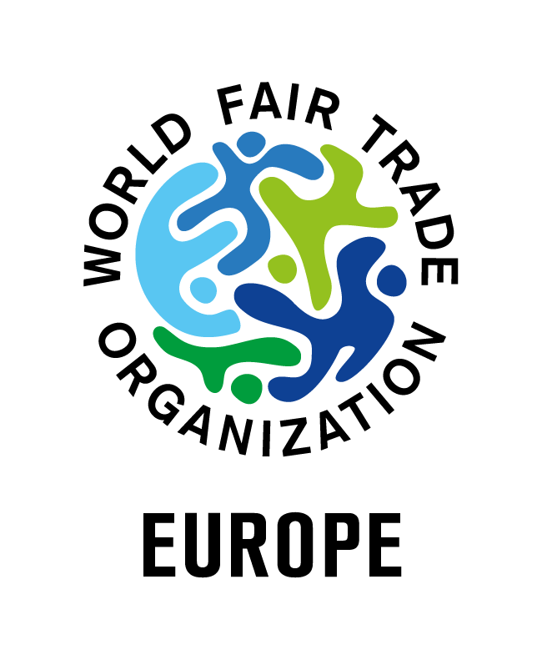
Minutes of the WFTO-Europe
2020 Annual General Meeting (AGM)

23rd June 2020, 10 am – 1 pm (CEST)
Online - Zoom

- Introduction

Welcoming speech by the President Juanjo Martínez.

Quorum: members present or represented by proxy

Out of 67 registered members, 40 were present or represented (29 present, and 11 represented by proxy). The quorum obligation was reached.

Members present

Fundacion Copade (Spain), EZA Fairer Handel GmbH (AT), Weltladen Dachverband e.V. (DE), Coordinatoria Estatal de Comercio Justo - CECJ (ES), Greater Goods (UK), Scottish Fair Trade Forum (UK), Equo Garantito (IT), Shared interest Limited (UK), U-landsforeningen Svalerne (SE), The Polish Fair Trade Association - PFTA (PL), FairMail Cards GmbH (DE), The Belgian Fair Trade Federation (BE), CMC Malongo (FR), Les Jardins de Gaïa (FR), EFTA (NL), El Puente GmbH (DE), Fair Trade Scotland Limited (UK), Oxfam Magasins du Monde (BE), The Organisation of Swedish Fair Trade Retailers (SE), Commerce Équitable France - CEF (FR), Oxfam Intermón (ES), Fédération Artisans du Monde (FR), Zotter Schokolade Manufaktur GmbH (AT), Gebana Ag (CH), Fair Band - Bundesverband für fairen Import und Vertrieb e.V. (DE), MYOMY (NL), Altromercato Impresa Sociale Soc. Coop. (IT), Traidcraft Exchange (UK), GEPA The Fair Trade Company (DE), Karethic (Terrethic) (FR)

Members represented by proxy

Fairtrade Czech Republic and Slovakia (CZ), Arbeitsgemeinschaft zur Förderung der Weltläden - ARGE (AT), CTM Agrofair (IT), BHCrafts doo (BH), Chotanagpurgruppe - Faire Handelsgesellschaft mbh (DE), Ökotopia Handels und Verlagsgesellschaft (DE), Ecoffins (UK), IDEAS - Iniciativas de Economía Alternativa y Solidaria (ES), Traidcraft Plc (UK), British Association of Fair Trade Shops - BAFTS (UK), Forum Fairer Handel e. V. (DE)

Non-voting members

Fundacion Isabel Martin (ES), Oxfam wereldwinkels (BE), Fundación Adsis - Equimercado (IT), Just Trading Scotland (UK), Szczyptaswiata Świata (PL)

Others

Erinch Sahan (CEO WFTO), Mikkel Norgard (WFTO-Europe Secretariat), Leida Rijnhout (WFTO-Europe Secretariat), Francesca Giubilo (WFTO-Europe Secretariat), Tess Hartmann-Hergott (WFTO-Europe Secretariat), Michael Fivet (Accountant)

- Appointment of the Chair and Secretary

The President proposed Leida Rijnhout as Chair and Francesca Giubilo as Secretary. Approved unanimously.

- Appointment of the Voting Committee

Francesca Giubilo and Tess Hartmann-Hergott (WFTO-Europe) volunteered to be part of the Voting Committee. Approved unanimously.

- Approval of the Minutes from the 2019 AGM in Brussels

The minutes were approved with 36 approval and only 2 abstentions.

- Presentation of 2019 Accounts and Balance

Michael Fivet, WFTO-Europe consultant on finance presented the 2019 accounts and balance. The figures showed a negative result of 8.431€. This was mainly due to the fact that several expenses foreseen within the Trade Fair Live Fair EU project were finally not done in 2019 but transferred in 2020. This change had an impact on the income side too. The final reserves of the organisation amount to 53.000€.

- Approval of 2019 Accounts and Balance. Discharge of the board of Directors for the accounts 2019

The accounts 2019 and the discharge of the Board of Directors were approved with 37 votes and 1 abstention.

- Budget 2020 update

On the income side, Michael Fivet showed that membership fees are higher than foreseen. However no income coming from the biennial conference, as this event was canceled due to the pandemic. Looking at the actual figures, the organisation might close the year with a positive balance of around 3.000€. Following some questions on human resources raised by members, the Treasurer and the secretariat explained that the staff time was not reduced due to the pandemic. As the Regional coordinator was coming back from maternity leave already on a part-time basis, her time was not cut more. Mikkel Norgard has been keeping his full time position as he will end his contract mi-September.

- Presentation of the 2021 provisional budget (and fees 2021)

Stephanie Brookes (Treasurer) presented the 2021 provisional budget and fees. With no more external projects and pandemic situation, the realistic budget presented showed a very critical financial situation. More specifically, because of the Covid situation, the initially planned increase in membership fees has been postponed to further notice. However the core costs of the organisation have been going up for years now and although the reduction of office running costs and travelling costs to counterbalance this effect, the result is insufficient. A need to gradually and proportionally increase the membership fees is crucial, but this will take place later in the year. On the funding side, unfortunately the proposals submitted by the Secretariat failed, which resulted in a lower forecast in incomes. However, fundraising still remains a priority. Regarding human resources, staff will be reduced from September on, with the “Trade Fair Live Fair” project ending which means the end of contract for Mikkel, and the fact that there will be only one intern instead of two. This staff reduction will result in a cut in the HR costs, but also means a more important workload concentrated on fewer people. Therefore, it is important that the WFTO-Europe members cooperate with the EU-office on fundraising projects, to increase the possibilities for financial support. The members can also assist the Secretariat in encouraging more organisations to join WFTO-Europe.

Questions:
- How likely is it to get grants/external funding? WFTO-Europe applied for some grants but failed because the times are challenging for small organizations and competition is high. The idea is now trying to diversify and apply for different types of grants. One interesting lead would be the EU Life program, proposing projects focusing on environmental issues. However, the co-funding part is high (45%), which would require a large consortium.
- Discussion on integrating an extra line on “expected funding” of 17.000 Euro, to put a concrete target for the secretariat/board. This idea was approved by the majority.

- Approval of the 2021 provisional budget

The provisional budget 2021 with one amendment (26 votes in favour of the amendment) was approved, with 34 votes and 6 abstentions.
The amendment consists in adding a line to the budget income-side including 17.000€, as a target to reach on the fundraising side.

- Presentation of the Annual Report 2019/20

The Coordinator went through the main points and highlights of the Annual report 2019 – 2020. Members welcomed and congratulated the staff for the great work done.

- Presentation of the Strategic plan and action plan 2020 - 2023

The President and chair presented the main points of the Strategic plan and Action plan 2020 – 2023 as well as the amendments that were agreed on during a WFTO-Europe consultation on the 3rd of June, 2020.

- Approval of the strategic plan and action plan 2020 – 2023

The plan with two amendments was approved with 38 votes and 1 abstention. Below the two amendments:
- Any references to the “promotion of other innovative business practices” will be replaced by a “cooperation with other innovative business practices”.
- The last sentence of the “Vision” section will be changed from “… fair and green economic model” to “…fair and sustainable economic model”.

- Presentation of co-opted and new candidates to the board of directors + Q&A

The terms of 2 board members (Estelle Vanwambeke, Oxfam MdM and Stephanie Brookes, Traidcraft Exchange) have come to an end in 2020 and are not being renewed, leaving their positions vacant.
Last year, two new board members had been co-opted (Cassandre Maury, Les Jardins de Gaïa and Jean-Christophe Galland, Malongo), and needed to be officially elected.
A new application for a board position by Charlotte Timson (Traidcraft Exchange).

- Nomination of the new Directors of the Board
The three candidates presented themselves and were officially appointed as Board members with the following results:
- Charlotte Timson: 32 votes in favour – 6 abstentions
- Jean-Christophe Galland: 35 votes in favour – 4 abstentions
- Cassandre Maury: 37 votes in favour, 2 abstentions

- Any Other Business (AOB)

Next year WFTO-Global’s AGM will be at the end of August – beginning of September in Berlin. WFTO-Europe members will be invited to join and to participate in a regional meeting that will be held there in parallel. An online AGM will be held during the first half of 2021 to vote and approve mandatory legal documents.

- End of the meeting

Last words from the President and end of the meeting, with special thanks to the organising team of this meeting, the outgoing board members and Mikkel Norgard, who ends his contract mid-September.

